**Citizen AI Chatbot – Ideation Phase**

**Brainstorm & Idea Prioritization Template**

| **Date** | **26 June 2025** |
| --- | --- |
| **Team ID** | *LTVIP2025TMID32134* |
| **Project Name** | Citizen AI Chatbot |
| **Maximum Marks** | 4 Marks |

**Objective**

Brainstorming fosters creative problem-solving for the **Citizen AI Chatbot**, an IBM Cloud-powered assistant designed to streamline government-citizen interactions. This template guides teams through ideation and prioritization.

**Reference**: [Mural.co Templates](https://www.mural.co/templates/brainstorm-and-idea-prioritization)

**Step 1: Team Gathering & Problem Statement**

**Define Your Problem Statement**

*What civic engagement challenges will the chatbot solve?*

*Example*:  
*"How might we use AI to reduce wait times for citizen queries about public services?"*

**Timebox**: 8 minutes

**Step 2: Brainstorm & Idea Listing**

**Guidelines**

* Generate **20+ ideas** (volume over perfection).
* Encourage wild, innovative solutions (e.g., *"Voice-enabled multilingual support"*).

**Categories to Explore**:

1. **User Experience** (e.g., "Conversational UI with sentiment analysis")
2. **Technical Feasibility** (e.g., "IBM Watson NLP integration")
3. **Government Pain Points** (e.g., "Automated FAQ responses for common queries")

**Timebox**: 15 minutes

| **Ideas** | **Category** |
| --- | --- |
| Real-time language translation | User Experience |
| IBM Granite for dynamic responses | Technical Feasibility |
| Dashboard for query analytics | Government Needs |

**Step 3: Idea Prioritization**

**Prioritization Grid**

Plot ideas based on **importance** (impact) and **feasibility** (ease of implementation).

**Timebox**: 30 minutes

| **Importance → Feasibility ↓** | **High** | **Low** |
| --- | --- | --- |
| **High** | **MVP Features**: - Basic Q&A with IBM Granite - Gradio UI | **Nice-to-Have**: - Voice support |
| **Low** | **Long-Term**: - Sentiment analysis dashboard | **Discard**: - Blockchain integration |

**Key Roles**

* **Facilitator**: Guides discussion, keeps time.
* **Scribe**: Documents ideas.
* **Stakeholders**: Government reps, developers.

**Next Steps**:

1. Finalize top 3 ideas for prototyping.
2. Assign owners for each idea.

**Screenshot Placeholders**

*(Insert your Gradio UI screenshots here with captions)*

1. **Chatbot Interface**

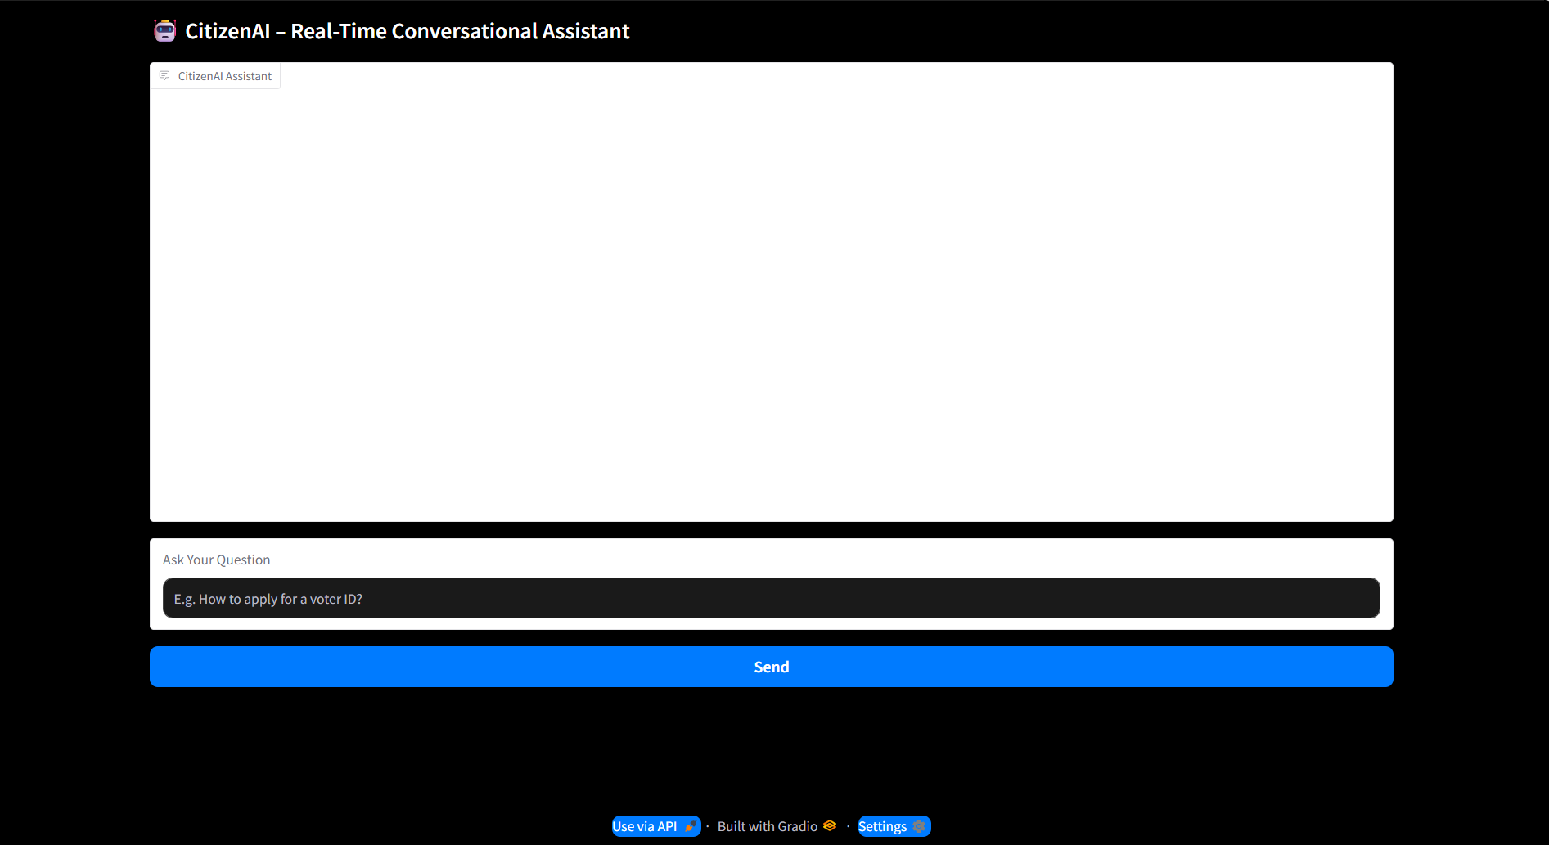

**2.Sentiment Analysis Demo**

